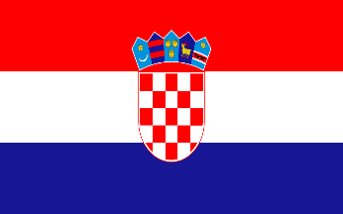


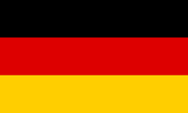

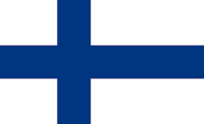

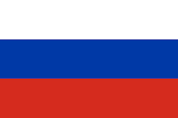
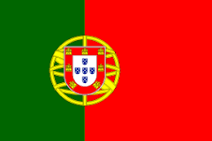
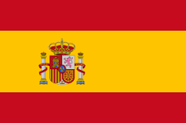
 |  |  |  | 1.
 |  |  |  |  |  |  |  |  | 5.
 |  |  |  |  |  |  |  |  |  |  |  |  | 6. |  |  |  |  |  | 9.
 | 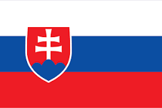 |  |  |  |  | 4.
2.
 |  |  | 3. |  |  |  |  |  |  |  |  |  |  |  | 10.
 |  |  |  |  |  |  |  |  |  |  |  | 7.
 | 
 |  |  |  |  |  |  | 8.
 |  |  |  |  |  |  |  |  |  |  |  |  |  | 11.
 |  |  |  |  | 12.
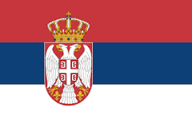 |  |  |  |  | 13.
Poznáš vlajky európskych štátov?
1.
2.
3.
4.
5.
6.
7.
8.
9.
10.
11.
12.
13.

